Cisco IPSec Site-to-Site VPN
A Practical Cisco IOS Lab

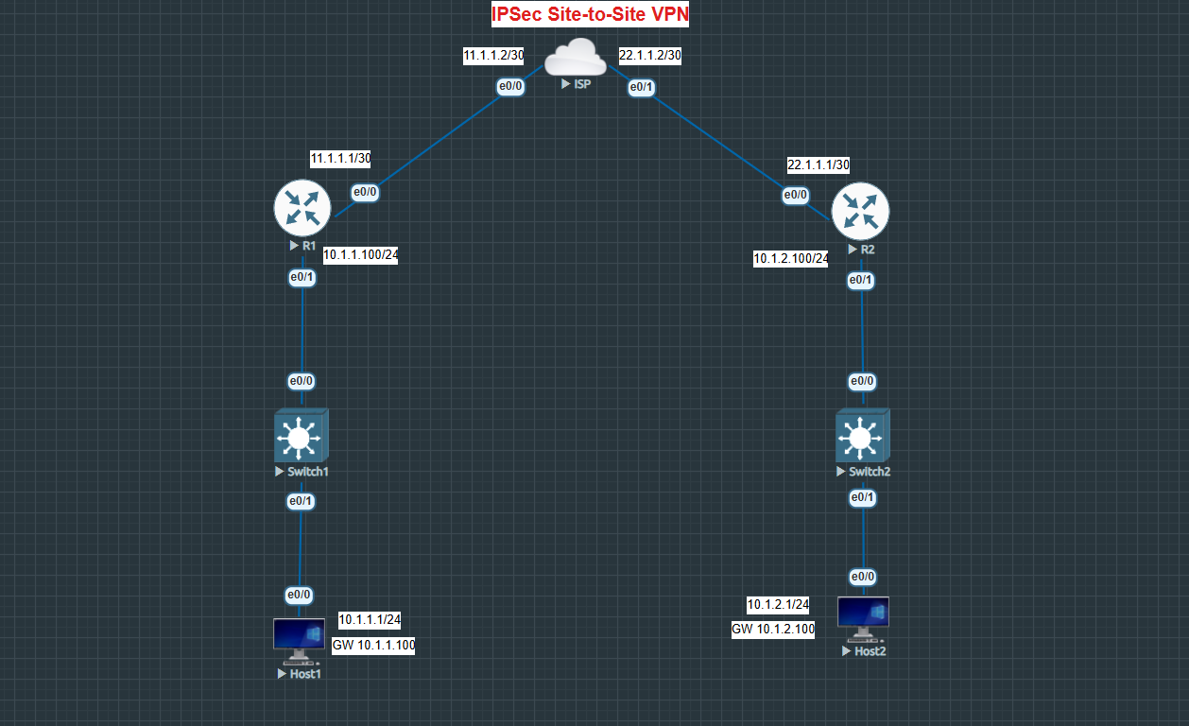
Portfolio / GitHub Project Documentation

Cisco IOS • IKE • IPSec • Crypto ACLs • Crypto Maps

1. Introduction
A site-to-site VPN is one of those networking technologies that becomes much easier to understand once it is built and tested. In this lab, two Cisco routers are used as VPN gateways, with an ISP router sitting between them. The objective is to securely connect the two private LANs so that hosts on one side can communicate with hosts on the other side through an IPSec tunnel.
The lab is intentionally small, but it demonstrates the main building blocks of a Cisco IOS IPSec site-to-site VPN: IKE policy, pre-shared-key authentication, an IPSec transform set, crypto ACLs, a crypto map, WAN routing, and verification.

2. Lab Objective
The main objective is to establish secure communication between the two private LANs:
10.1.1.0/24 <==== IPSec VPN ====> 10.1.2.0/24
R1 acts as the VPN gateway for Site 1 and R2 acts as the VPN gateway for Site 2. The ISP router represents the provider/public network between the two sites.

3. Topology
The topology contains R1, R2, an ISP router, a switch and host at each site. The WAN links use /30 networks, while each internal LAN uses a /24 network.

4. Addressing Plan
Device | Interface | IP Address | Purpose
R1 | Ethernet0/0 | 11.1.1.1/30 | WAN / VPN peer interface
ISP | Ethernet0/0 | 11.1.1.2/30 | Provider side toward R1
ISP | Ethernet0/1 | 22.1.1.2/30 | Provider side toward R2
R2 | Ethernet0/0 | 22.1.1.1/30 | WAN / VPN peer interface
R1 | Ethernet0/1 | 10.1.1.100/24 | Site 1 LAN gateway
R2 | Ethernet0/1 | 10.1.2.100/24 | Site 2 LAN gateway
Host1 | LAN | 10.1.1.1/24 | Site 1 test host
Host2 | LAN | 10.1.2.1/24 | Site 2 test host

5. How the VPN Works
The VPN can be understood as a chain of decisions. First, normal IP routing provides reachability to the VPN peers. Then the crypto ACL identifies traffic that should be protected. The crypto map ties the peer, transform set and ACL together. Finally, the crypto map is applied to the WAN interface.
Interesting Traffic
↓
Crypto ACL
↓
Crypto Map
↓
IKE / IPSec negotiation
↓
Encrypted traffic across ISP
↓
Remote VPN gateway
↓
Remote LAN

6. IKE Phase 1
The first stage establishes the IKE security association between R1 and R2. The lab uses AES encryption, SHA-256 hashing, pre-shared-key authentication and Diffie-Hellman group 5.
crypto isakmp policy 10
encr aes
hash sha256
authentication pre-share
group 5
R1 identifies R2 as its peer using 22.1.1.1, while R2 identifies R1 using 11.1.1.1. The lab uses the pre-shared key cisco123. This is suitable for a lab demonstration only; a production VPN should use a strong, unique secret.
R1:
crypto isakmp key cisco123 address 22.1.1.1
R2:
crypto isakmp key cisco123 address 11.1.1.1

7. IPSec Phase 2
After IKE has established the required security association, IPSec parameters are used to protect the actual data traffic. The transform set in this lab uses ESP with AES encryption and SHA HMAC integrity in tunnel mode.
crypto ipsec transform-set TRANS esp-aes esp-sha-hmac
mode tunnel

8. Identifying Interesting Traffic
The crypto ACL determines which traffic should be protected by IPSec. On R1, traffic from the Site 1 LAN to the Site 2 LAN is selected. On R2, the reverse direction is selected.
R1:
access-list 100 permit ip 10.1.1.0 0.0.0.255 10.1.2.0 0.0.0.255
R2:
access-list 100 permit ip 10.1.2.0 0.0.0.255 10.1.1.0 0.0.0.255
This ACL is referenced by the crypto map. In other words, it tells the router which traffic should be treated as VPN traffic rather than simply forwarded normally.

9. Crypto Map
The crypto map brings the VPN configuration together. It identifies the remote peer, the transform set used to protect traffic, and the ACL that defines interesting traffic.
R1:
crypto map CRPMAP 10 ipsec-isakmp
set peer 22.1.1.1
set transform-set TRANS
match address 100
R2:
crypto map CRPMAP 10 ipsec-isakmp
set peer 11.1.1.1
set transform-set TRANS
match address 100

10. Applying the Crypto Map
The crypto map must be applied to the WAN interface. This is the interface through which the VPN traffic leaves each router.
R1:
interface Ethernet0/0
ip address 11.1.1.1 255.255.255.252
crypto map CRPMAP
R2:
interface Ethernet0/0
ip address 22.1.1.1 255.255.255.252
crypto map CRPMAP

11. Routing
IPSec does not replace IP routing. The VPN gateways still need a route toward the provider network and the remote peer. In this lab, each router uses a default route toward the ISP.
R1:
ip route 0.0.0.0 0.0.0.0 11.1.1.2
R2:
ip route 0.0.0.0 0.0.0.0 22.1.1.2

12. What Happens When Host1 Pings Host2?
- Host1 sends traffic destined for 10.1.2.1 to its default gateway, R1 at 10.1.1.100.
- R1 sees that the traffic from 10.1.1.0/24 to 10.1.2.0/24 matches crypto ACL 100.
- If the VPN security associations are not already established, R1 and R2 negotiate them.
- R1 protects the traffic using the configured IPSec parameters.
- The encrypted traffic crosses the ISP network between the two VPN gateways.
- R2 receives, validates and decrypts the IPSec traffic.
- R2 forwards the original traffic to Host2 on the 10.1.2.0/24 LAN.
- The reply follows the reverse process.

13. The Role of the ISP
The ISP router is deliberately simple. It provides the network between the two VPN gateways but does not participate in the IPSec configuration. The relevant provider interfaces are 11.1.1.2/30 toward R1 and 22.1.1.2/30 toward R2. The ISP also has Loopback1 configured as 8.8.8.8/24.
interface Ethernet0/0
ip address 11.1.1.2 255.255.255.252
interface Ethernet0/1
ip address 22.1.1.2 255.255.255.252
interface Loopback1
ip address 8.8.8.8 255.255.255.0

14. Verification
A useful troubleshooting habit is to verify the lab in layers rather than immediately assuming that a failed end-to-end ping means the IPSec configuration is wrong.
- Verify that the interfaces are up.
- Verify basic WAN connectivity between each router and the ISP.
- Check the routing table.
- Check the IKE policy and IKE security association.
- Check the IPSec security association.
- Generate interesting traffic between the two LANs.
- Check IPSec packet counters to confirm that traffic is being encapsulated and decrypted.
Useful Cisco verification commands include:
show ip interface brief
show ip route
show crypto isakmp policy
show crypto isakmp sa
show crypto ipsec sa

15. Troubleshooting Method
1. Interface status
↓
2. WAN connectivity
↓
3. Routing
↓
4. IKE configuration
↓
5. IPSec configuration
↓
6. Crypto ACL
↓
7. Crypto map
↓
8. End-to-end traffic
For example, if R1 cannot reach the ISP, there is little value in troubleshooting the IPSec tunnel first. If the WAN path works but IKE does not establish, the focus should move to the IKE policy and pre-shared key. If the tunnel establishes but LAN traffic does not pass, the crypto ACL, routing and IPSec counters become especially important.

16. R1 VPN Configuration
crypto isakmp policy 10
encr aes
hash sha256
authentication pre-share
group 5
crypto isakmp key cisco123 address 22.1.1.1
crypto ipsec transform-set TRANS esp-aes esp-sha-hmac
mode tunnel
crypto map CRPMAP 10 ipsec-isakmp
set peer 22.1.1.1
set transform-set TRANS
match address 100
interface Ethernet0/0
ip address 11.1.1.1 255.255.255.252
crypto map CRPMAP
interface Ethernet0/1
ip address 10.1.1.100 255.255.255.0
ip route 0.0.0.0 0.0.0.0 11.1.1.2
access-list 100 permit ip 10.1.1.0 0.0.0.255 10.1.2.0 0.0.0.255

17. R2 VPN Configuration
crypto isakmp policy 10
encr aes
hash sha256
authentication pre-share
group 5
crypto isakmp key cisco123 address 11.1.1.1
crypto ipsec transform-set TRANS esp-aes esp-sha-hmac
mode tunnel
crypto map CRPMAP 10 ipsec-isakmp
set peer 11.1.1.1
set transform-set TRANS
match address 100
interface Ethernet0/0
ip address 22.1.1.1 255.255.255.252
crypto map CRPMAP
interface Ethernet0/1
ip address 10.1.2.100 255.255.255.0
ip route 0.0.0.0 0.0.0.0 22.1.1.2
access-list 100 permit ip 10.1.2.0 0.0.0.255 10.1.1.0 0.0.0.255

18. Lessons Learned
This lab demonstrates that a working site-to-site VPN is not a single command. Several components have to agree: routing must provide reachability, IKE must negotiate correctly, the IPSec transform set must match, the crypto ACLs must identify the intended traffic, and the crypto map must be attached to the correct interface.
- A VPN does not replace routing.
- The crypto ACL defines the traffic that should be protected.
- The peer address must point to the remote VPN gateway.
- The transform-set configuration must be compatible on both peers.
- The crypto map must be applied to the correct WAN interface.
- Packet counters are useful evidence when verifying that IPSec is actually processing traffic.

19. Production Considerations
This is a learning lab rather than a production design. The configuration uses a simple pre-shared key and a legacy-style Cisco IOS IPSec setup. A production deployment should review cryptographic algorithms and Diffie-Hellman parameters against current platform support and organizational security requirements.
- Use strong, unique VPN credentials.
- Use current cryptographic standards supported by the platform.
- Consider redundancy and VPN failover.
- Define routing carefully rather than relying on simple default routes in larger environments.
- Consider firewall and NAT requirements.
- Enable appropriate logging and monitoring.
- Document key management and change procedures.

20. Suggested GitHub Repository Structure
cisco-ipsec-site-to-site-vpn/
│
├── README.md
├── topology/
│ └── ipsec-site-to-site.png
├── configs/
│ ├── R1.txt
│ ├── R2.txt
│ └── ISP.txt
├── verification/
│ ├── show-crypto-isakmp-sa.txt
│ ├── show-crypto-ipsec-sa.txt
│ └── ping-tests.txt
└── notes/
└── troubleshooting.md

21. Conclusion
The main value of this lab is not simply getting Host1 to ping Host2. The important part is understanding the relationship between routing, IKE, IPSec, crypto ACLs and crypto maps. Once those pieces are understood, the Cisco commands become much easier to reason about and troubleshoot.
This project also provides a compact example of practical Cisco configuration work. Including the topology, configurations, verification output and troubleshooting notes in the GitHub repository makes the project easier for another engineer to reproduce and review.

22. IKE Phase 1 and Phase 2 Message Exchange
The configuration shows that this lab uses the Cisco IOS crypto isakmp configuration, so the VPN is based on IKEv1. The earlier sections explain what Phase 1 and Phase 2 configure; this section goes one step further and explains the messages exchanged between R1 and R2 during tunnel establishment.
The exact packet contents are not present in the supplied running-config files. Therefore, the message sequence below describes the normal IKEv1 Main Mode and Quick Mode process that corresponds to this type of configuration. A packet capture would be required to claim that these exact messages were observed in this particular lab run.

22.1 Phase 1 — IKEv1 Main Mode
Phase 1 creates the secure IKE/ISAKMP Security Association between R1 and R2. In this lab, the peers negotiate AES encryption, SHA-256 hashing, pre-shared-key authentication and Diffie-Hellman group 5.
R1 R2
| |
|--- 1. IKE SA proposal -----------------------> |
|<-- 2. Selected IKE proposal ------------------ |
|--- 3. DH public value + nonce --------------> |
|<-- 4. DH public value + nonce --------------- |
|--- 5. Encrypted identity + authentication --> |
|<-- 6. Encrypted identity + authentication --- |
| |
| IKE/ISAKMP Security Association |

22.2 Main Mode Messages in Plain English
Message | Direction | What happens | Why it matters
Message 1 | R1 → R2 | R1 proposes its IKE security parameters. | The proposal includes the algorithms and Diffie-Hellman parameters R1 is willing to use.
Message 2 | R2 → R1 | R2 selects a compatible proposal. | R2 responds with the IKE parameters it has selected from the proposal.
Message 3 | R1 → R2 | R1 sends its Diffie-Hellman public value and nonce. | These values contribute to creating shared keying material.
Message 4 | R2 → R1 | R2 sends its Diffie-Hellman public value and nonce. | R1 and R2 can now derive the shared secret without sending the secret itself.
Message 5 | R1 → R2 | R1 sends encrypted identity and authentication information. | The identity/authentication exchange is protected using the negotiated IKE parameters.
Message 6 | R2 → R1 | R2 sends its encrypted identity and authentication information. | After successful authentication, the IKE Security Association is established.

22.3 What Phase 1 Achieves
At the end of Phase 1, R1 and R2 have authenticated each other and established an IKE Security Association. This gives the peers a protected channel for negotiating the IPSec Security Associations used to protect the actual site-to-site data.

22.4 Phase 2 — IKEv1 Quick Mode
Phase 2 uses Quick Mode to negotiate the IPSec Security Associations. This is where the peers agree on how the actual user traffic will be protected. In this lab, the crypto ACLs identify the traffic between 10.1.1.0/24 and 10.1.2.0/24.
R1 R2
| |
|--- 1. Quick Mode proposal + nonce ----------> |
|<-- 2. Quick Mode response + nonce ----------- |
|--- 3. Quick Mode confirmation --------------> |
| |
| IPSec Security Associations |
| |
|==== Encrypted Site-to-Site Traffic ==========> |

22.5 Quick Mode Messages in Plain English
Message | Direction | What happens | Why it matters
Message 1 | R1 → R2 | R1 proposes the IPSec parameters and identifies the traffic to be protected. | This negotiation is based on the crypto configuration, including the transform set and traffic selectors/proxy identities.
Message 2 | R2 → R1 | R2 accepts a compatible IPSec proposal and returns its negotiation values. | Both peers now have matching parameters for the IPSec Security Association.
Message 3 | R1 → R2 | R1 sends the final Quick Mode confirmation. | The Phase 2 negotiation is completed and the IPSec Security Associations can be used for data traffic.

22.6 Connecting the Messages to This Lab
The message exchange can be connected directly to the configuration. R1 identifies R2 as 22.1.1.1 and R2 identifies R1 as 11.1.1.1. Both routers use the same IKE policy, pre-shared-key authentication and transform set. The crypto ACLs then define the LAN traffic that should be protected.
R1 WAN: 11.1.1.1/30
R2 WAN: 22.1.1.1/30
R1 peer: 22.1.1.1
R2 peer: 11.1.1.1
IKE: AES / SHA-256 / PSK / DH Group 5
IPSec: ESP-AES / SHA-HMAC
R1 traffic: 10.1.1.0/24 → 10.1.2.0/24
R2 traffic: 10.1.2.0/24 → 10.1.1.0/24

22.7 Complete Tunnel Establishment Flow
PHASE 1 — IKEv1 Main Mode
6 messages
│
▼
IKE / ISAKMP Security SA
│
▼
PHASE 2 — Quick Mode
3 messages
│
▼
IPSec Security SAs
│
▼
Encrypted LAN-to-LAN Traffic
│
10.1.1.0/24 ↔ 10.1.2.0/24

22.8 Verifying the Negotiation on Cisco IOS
The running configurations show what is configured, but verification commands show whether the negotiation actually took place. After generating traffic, the following commands are useful:
show crypto isakmp sa
show crypto ipsec sa
The IKE command is useful for checking the Phase 1 Security Association. The IPSec command is useful for checking Phase 2 and the packet counters. Increasing encapsulation and encryption counters after a ping between the LANs provide useful evidence that traffic is being processed by IPSec.

22.9 Why This Matters
Looking at the messages makes the configuration easier to understand. The commands are not isolated lines: the IKE policy controls Phase 1, the pre-shared key authenticates the peers, the transform set defines how the data is protected, the crypto ACL identifies the interesting traffic, and the crypto map ties these pieces together.

